**QUERY SOLUTION**

--WHO ARE ALL THE OPPONENTS FOR BOTH THE PLAYERS?

SELECT opponent, COUNT(opponent) AS freqency_opponents FROM cr_vs_leo

GROUP BY player,opponent

TABLE:

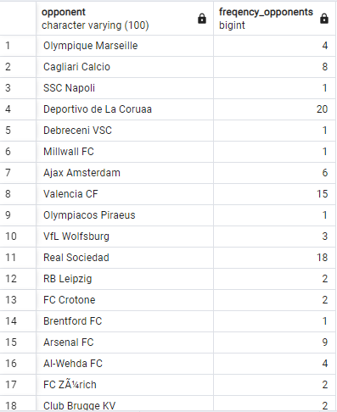

DATA VISUALIZATION:

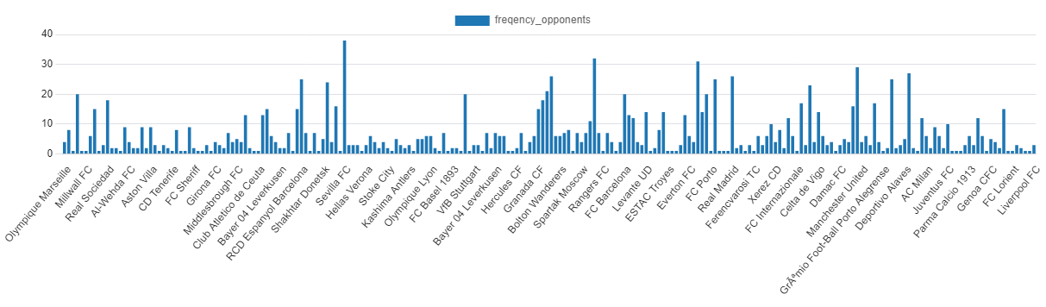

--WHAT ARE THE VARIOUS COMPETITIONS THE PLAYERS PLAYED?

SELECT DISTINCT(competition) FROM cr_vs_leo

TABLE:

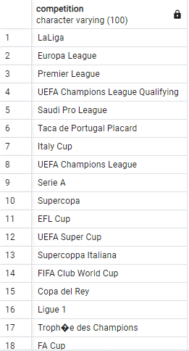

--IS THE GAME PLAY MOSTLY AWAY THE HOME TOWN OR IN THE HOMETOWN? H OR A

SELECT venue,player ,COUNT(*) FROM cr_vs_leo

GROUP BY venue,player

TABLE:

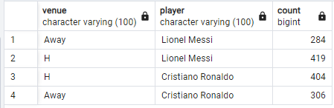

DATA VISUALIZATION:

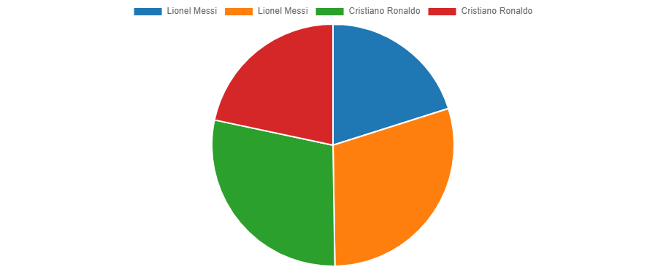

--COUNT OF PLAYERS WHO MADE HEAD SHOTS?

SELECT player , kicks ,COUNT(*) AS HEAD_SHOTS_COUNT FROM cr_vs_leo WHERE kicks='Header'

GROUP BY player , kicks

TABLE:

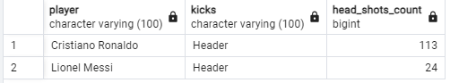

DATA VISUALIZATION:

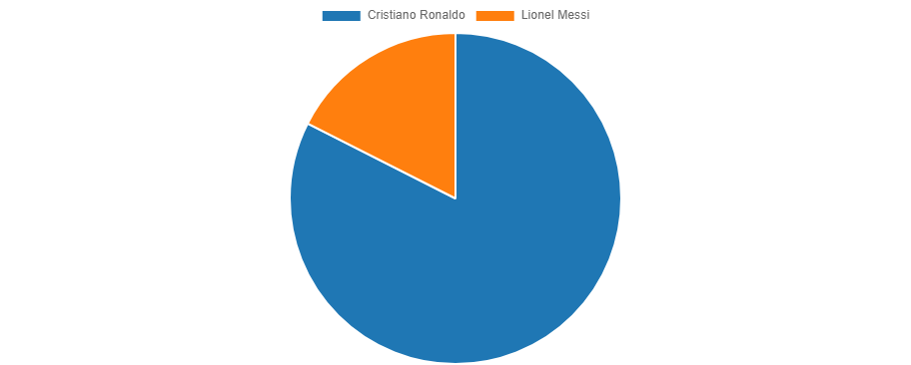

--WHO HAS A HISTORY OF PLAYING A LONG TIME IN LALIGA?

SELECT player ,competition, COUNT(*) AS LaLiga_COUNT FROM cr_vs_leo WHERE competition=’LaLiga’

GROUP BY player,competition

TABLE:

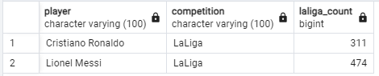

DATA VISUALIZATION:

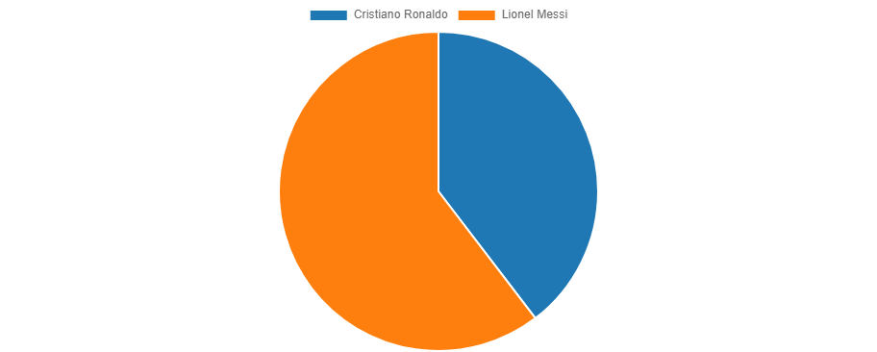

--WHAT ARE ALL THE VARIOUS TYPE OF KICKS THE PLAYERS MADE?

SELECT DISTINCT(KICKS)FROM cr_vs_leo

TABLE:

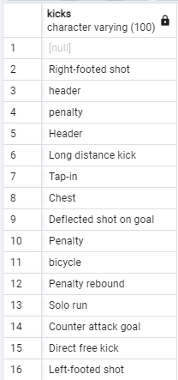

--WHAT WAS THE FREQUENTLY VISITED COMPETITION BY CRISTIANO RONALDO?

SELECT 'Cristiano Ronaldo' AS PLAYERS,competition AS competitions,COUNT(*) AS competition_COUNT FROM cr_vs_leo

GROUP BY competition

DATA VISUALIZATION:

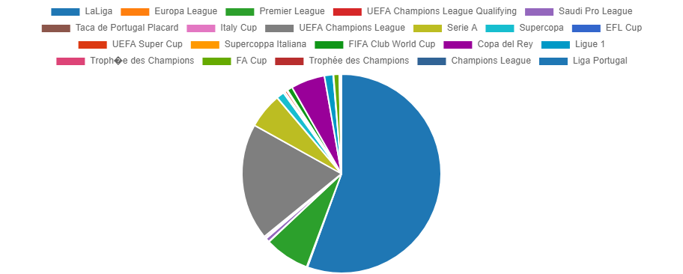

TABLE:

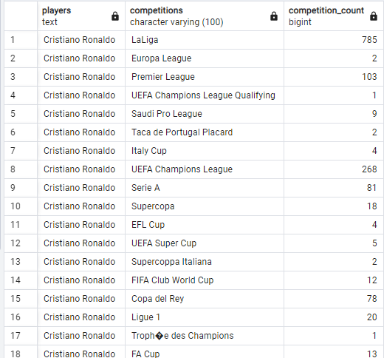

--CRISTIANO'S TOTAL FIFA CLUB WORLD CUP PLAYED "AWAY"?

SELECT player,venue,COUNT(*) FROM cr_vs_leo

GROUP BY player,venue

TABLE:

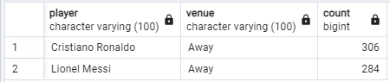

DATA VISUALIZATION:

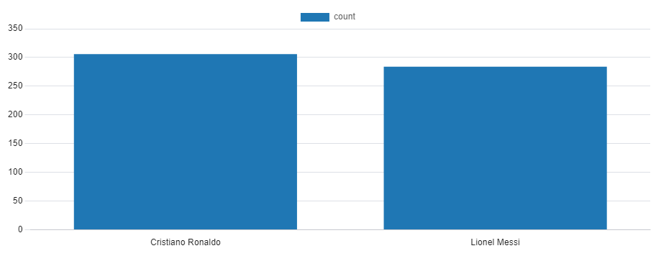

--WHAT ARE ALL THE CLUBS CRISTIANO RONALDO SPEND THEIR MAXIMUM TIME?

SELECT player,club,COUNT(*) FROM cr_vs_leo

GROUP BY player,club

TABLE:

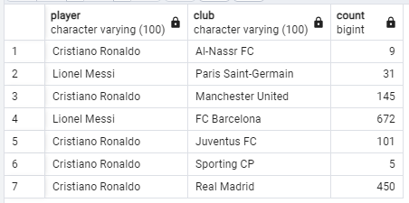

DATA VISUALIZATION:

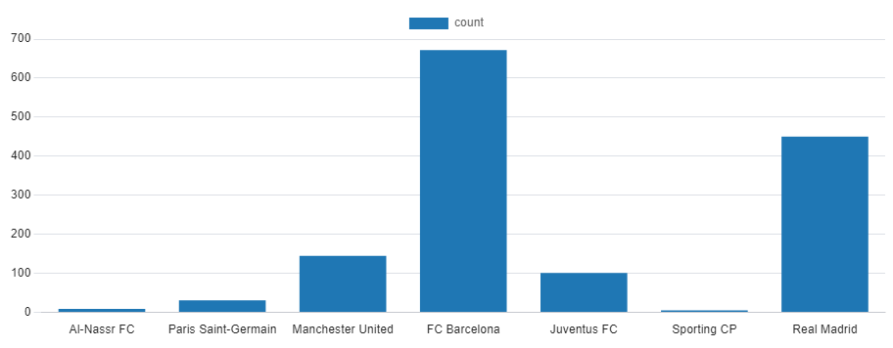

--WHO HAD MAXIMUM LEFT_FOOTED SHOT?

SELECT player,kicks, COUNT(*) AS max_leftfoot FROM cr_vs_leo

GROUP BY player,kicks

DATA VISUALIZATION:

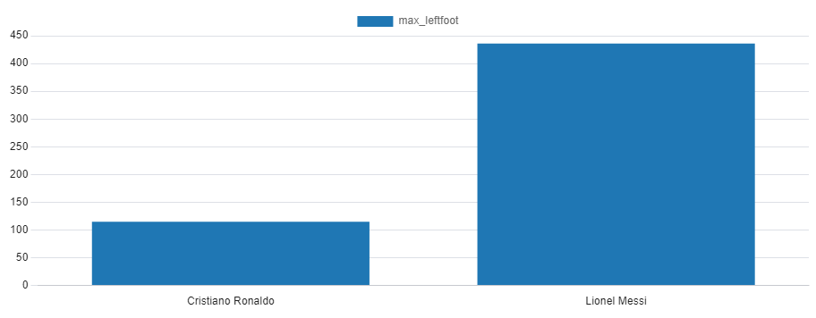

TABLE:

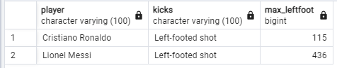

--WHAT ARE ALL THE CLUBS LIONEL MESSI SPEND THEIR MAXIMUM TIME?

SELECT 'lionel Messi' AS player,club,COUNT(*) FROM cr_vs_leo

GROUP BY player,club

TABLE:

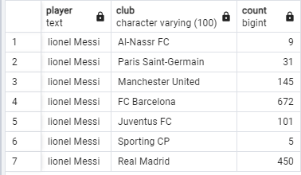

DATA VISUALIZATION:

